EXPERIMENT 4
DATA MODELLING AND FORM DESIGN FOR A BUSINESS APPLICATION IN ZOHO CREATOR
Gym Membership Enrollment & Front Desk Management

Parikshith P
Reg. No: 2116241401062
Computer Science and Business Systems
Rajalakshmi Engineering College, Chennai

Application: Gym Membership Enrollment & Front Desk Management
Form: Membership_Enrollment_Form
Report: Membership_Enrollment_Form Report

1. Aim
To design and develop a gym membership enrollment application using Zoho Creator by applying data modelling principles, configuring appropriate form fields, organizing information into logical sections, and collecting member details through a structured digital form.

2. Problem Statement
Traditional gym enrollment procedures often rely on paper-based registration forms. These methods can result in incomplete information, illegible entries, missing emergency contact details, and difficulty tracking membership preferences.
The proposed application digitizes the enrollment process by collecting personal details, contact information, membership preferences, fitness goals, scheduling preferences, and health declarations through a single form. The collected information can be stored as structured records and accessed by gym staff for verification and member onboarding.

3. Software and Tools Required
- Zoho Creator account
- Web browser
- Zoho Creator Form Builder
- Zoho Creator Reports
- Internet connection

4. Application Design
The application was created in Zoho Creator using the Create from Scratch option. The application was named Gym Membership Enrollment & Front Desk Management.
The form was designed as Membership_Enrollment_Form and organized into four logical sections to improve readability and make data entry easier.

4.1 Section A — Member Details
This section captures the member's basic identity and enrollment category.
Field | Data type | Purpose
Member Name | Name | Stores the member's first and last name
Age | Number | Records the member's age
Membership Type | Radio | Selects New Member, Renewal, or Corporate Enrollment

4.2 Section B — Contact Details

This section collects information required for communication and emergency purposes.
Field | Data type | Purpose
Email Address | Email | Stores the member's email address
Contact Number | Phone | Records the member's phone number
Residential Address | Address | Captures address lines, city, state, postal code, and country
Emergency Contact Name | Single Line | Records the emergency contact person's name

4.3 Section C — Membership and Fitness Preferences

This section records the member's preferred membership plan and fitness requirements.
Field | Data type | Purpose
Membership Plan | Drop Down | Allows selection of a membership plan
Preferred Activities | Multi Select | Allows selection of one or more fitness activities
Fitness Goals / Medical Notes | Multi Line | Records fitness objectives and relevant health information

4.4 Section D — Scheduling and Health Declaration

This section captures scheduling preferences and the member's declaration.
Field | Data type | Purpose
Preferred Start Date | Date | Records the intended membership start date
Preferred Workout Slot | Time | Captures the preferred workout time
Health Declaration Waiver | Checkbox | Records agreement to the fitness declaration and waiver
The form uses thirteen basic field types provided by Zoho Creator. Each field is selected according to the type of information it needs to store.
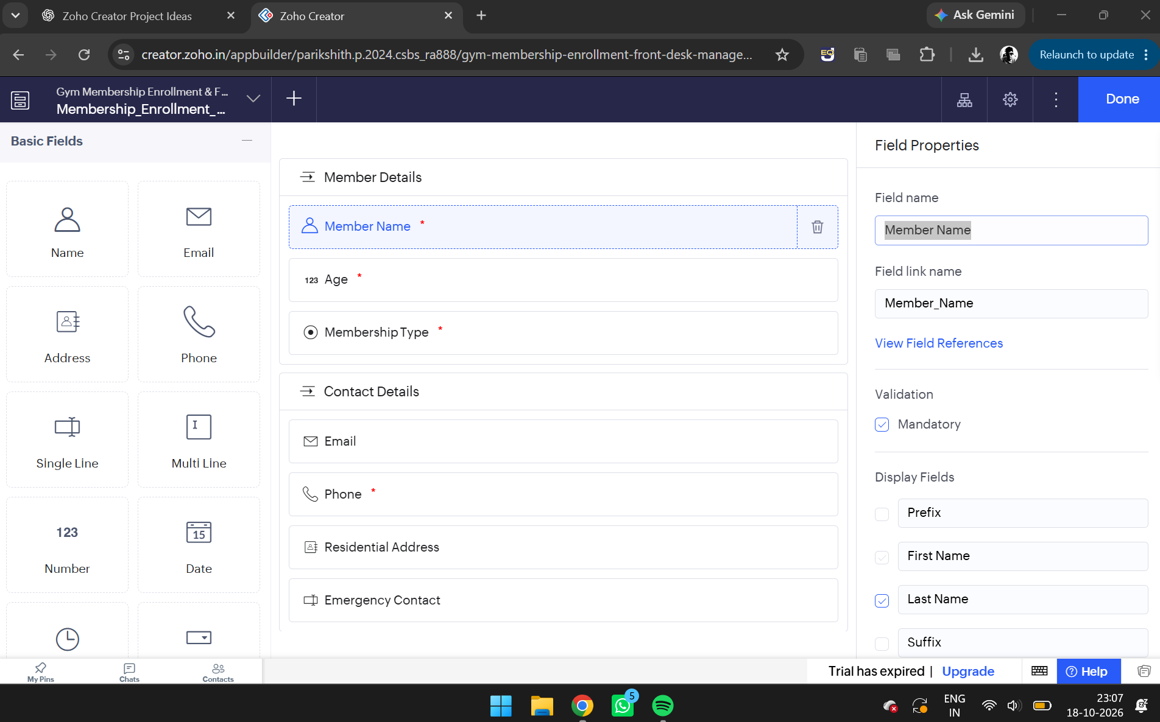
Figure 1. Zoho Creator Form Builder showing the available basic fields and the current form layout.

5. Procedure
- Open Zoho Creator and sign in using the registered account.
- Select the option to create a new application from scratch.
- Enter the application name as Gym Membership Enrollment & Front Desk Management.
- Open the Form Builder and create a form named Membership_Enrollment_Form.
- Add the required basic fields from the field palette.
- Configure the field labels and link names according to the enrollment requirements.
- Arrange the fields under Member Details, Contact Details, Membership and Fitness Preferences, and Scheduling and Health Declaration.
- Configure the available field properties, mandatory settings, and validation rules.
- Save the form and open its live preview to inspect the layout.
- Enter sample member details and submit enrollment records.
- Open the associated report to verify that the submitted records are stored correctly.

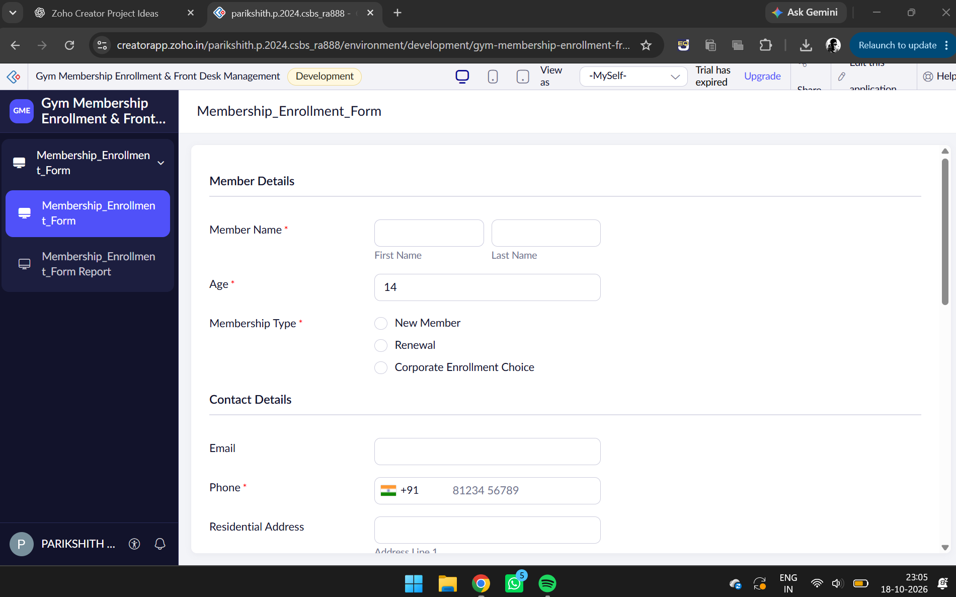
Figure 2. Live form preview showing the Member Details and Contact Details sections.

6. Field Validation and Data Integrity
Validation rules help maintain the quality and consistency of submitted information.
The following validation requirements were specified for the application:
- Mandatory fields: Member Name, Contact Number, Age, Membership Type, Membership Plan, and Health Declaration Waiver.
- Email validation: The email field should accept valid email addresses.
- Phone validation: The phone field should support Indian phone numbers.
- Age validation: The permitted age range should be from 14 to 75 years.
- Date validation: The preferred start date should not be earlier than the current date.
- Health declaration: Submission should require agreement to the waiver.

These rules reduce incomplete submissions and help maintain consistent enrollment records. Each rule should be verified in the field properties and through test submissions before the application is considered fully validated.

7. Live Form Preview
The live preview displays the enrollment form as it will appear to a user entering membership details. It provides an opportunity to inspect field labels, input controls, mandatory indicators, and section organization.
The preview also helps identify layout issues before the application is used for actual data entry. The Name field provides separate first-name and last-name inputs, while the Address field provides separate address components. Selection fields offer predefined choices, reducing inconsistent entries.
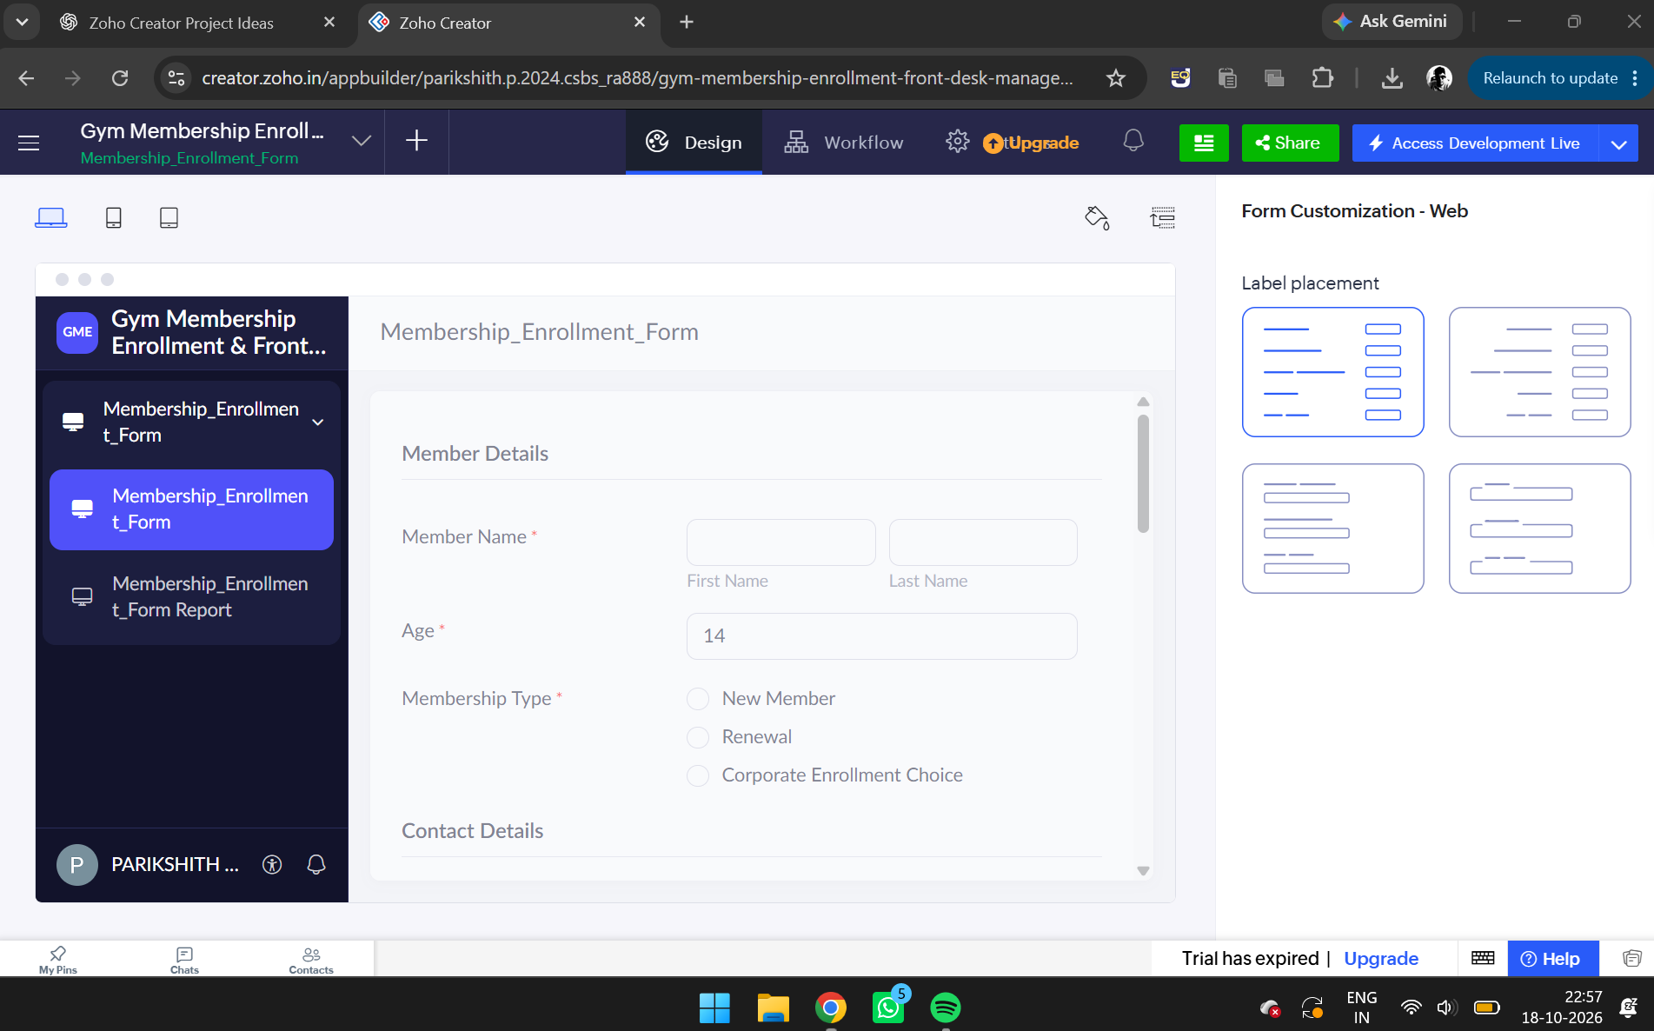
Figure 3. Live form showing the form title, fields, and mandatory indicators.

8. Report Generation and Record Management
Zoho Creator provides report views for displaying records submitted through a form. The associated membership enrollment report can be used by gym staff to review member details, compare membership plans, and inspect preferred start dates and activities.
The report supports structured access to enrollment data and makes it easier to identify records requiring verification. At least three sample records should be submitted and checked in the report to demonstrate that the form stores data successfully.
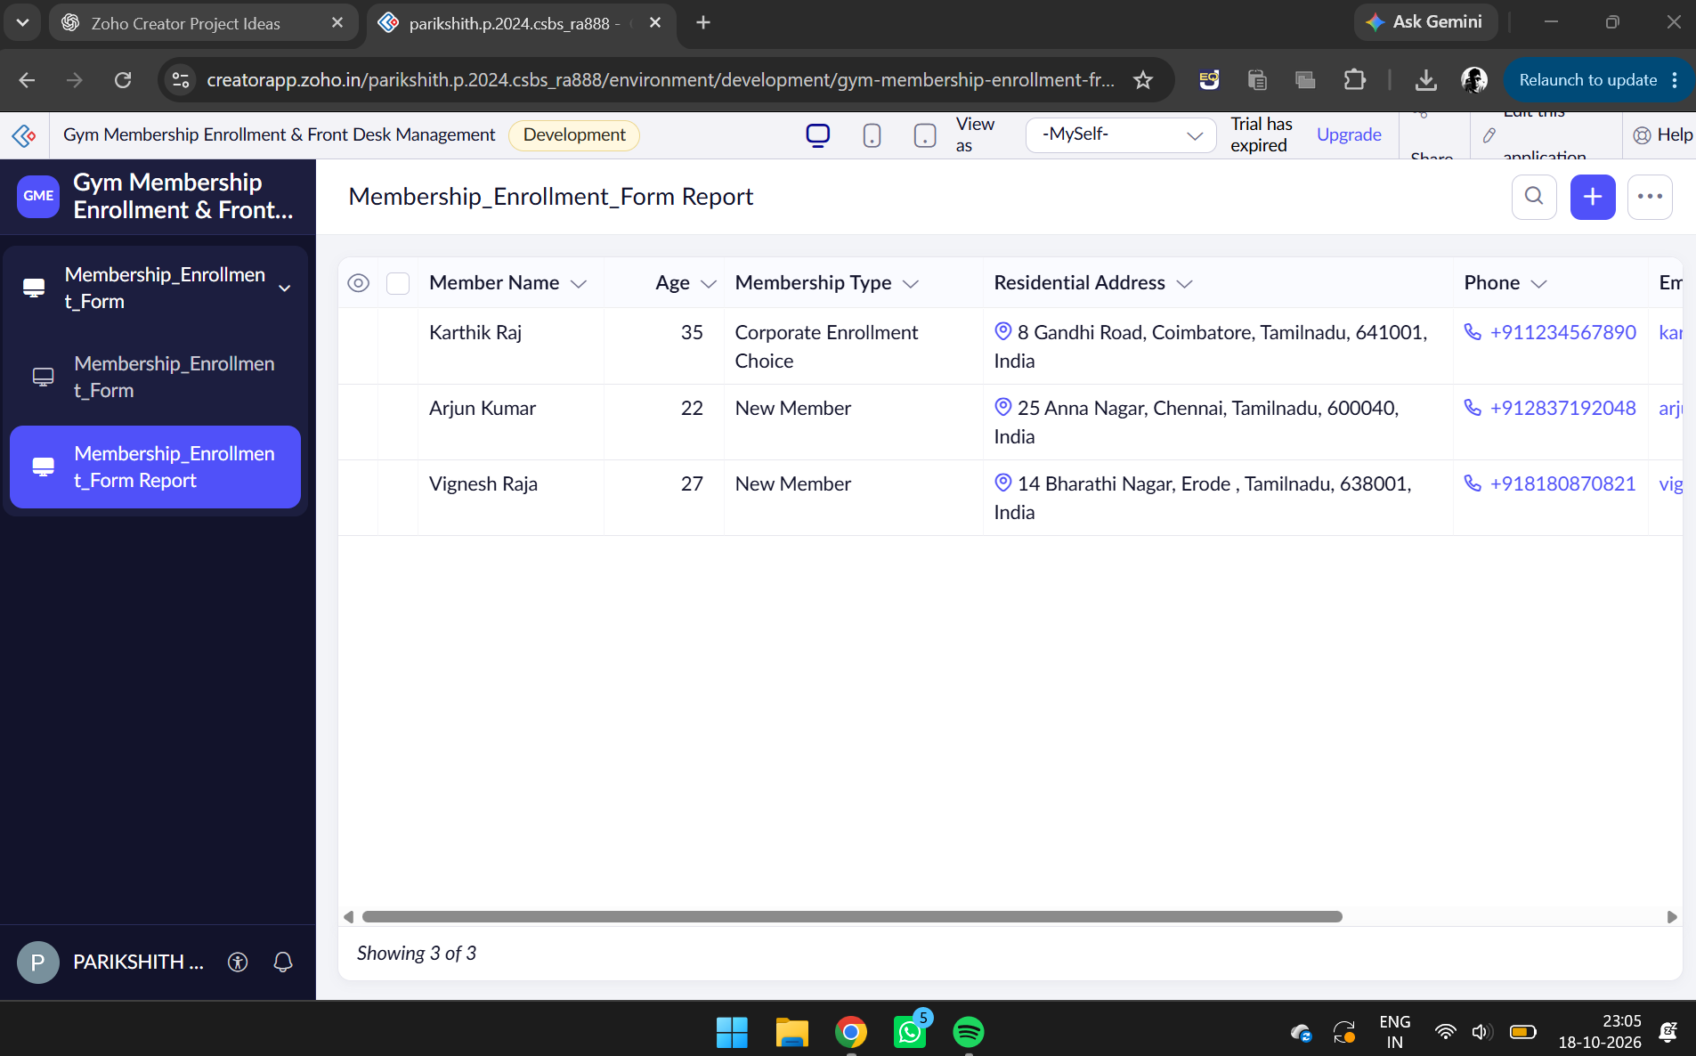
Figure 4. Membership_Enrollment_Form Report displaying submitted membership enrollment records.

9. Testing
The application should be tested using valid and invalid input values.
Test case | Expected result
Submit a valid enrollment | Record is saved successfully
Leave a mandatory field empty | Form displays a validation message
Enter an invalid email address | Email validation prevents invalid input
Enter an age below 14 or above 75 | Age validation rejects the value
Select a past start date | Date validation prevents the selection or submission
Leave the health declaration unchecked | Submission is prevented
Open the enrollment report | Submitted records are displayed

The expected results should be compared with the actual behavior of the application. Any validation that is unavailable or incorrectly configured should be corrected before final submission.

10. Result
A gym membership enrollment application was designed using Zoho Creator's visual Form Builder. The form structure includes member details, contact information, membership and fitness preferences, and scheduling and health declaration fields.
The application demonstrates how a low-code platform can organize business data using different field types and provide a structured interface for collecting enrollment information. The report view and validation rules support accurate record management and member onboarding.
The experiment is considered complete after the required field configuration, validation checks, and report verification have been demonstrated.

11. Conclusion
This experiment demonstrates the use of Zoho Creator for data modelling and form design in a practical business scenario. By selecting suitable field types, organizing related information into sections, and applying validation rules, a traditional paper-based enrollment process can be converted into a structured digital workflow.
The application provides a foundation for further enhancements, including automated confirmation emails, membership approval workflows, dashboards, and role-based access control.

12. Reference
Assignment 02 — Gym Membership Enrollment Form: Basic Fields Use Case, Department of Computer Science and Engineering, Rajalakshmi Engineering College.

